Lois des noeuds.

Exercice 1:

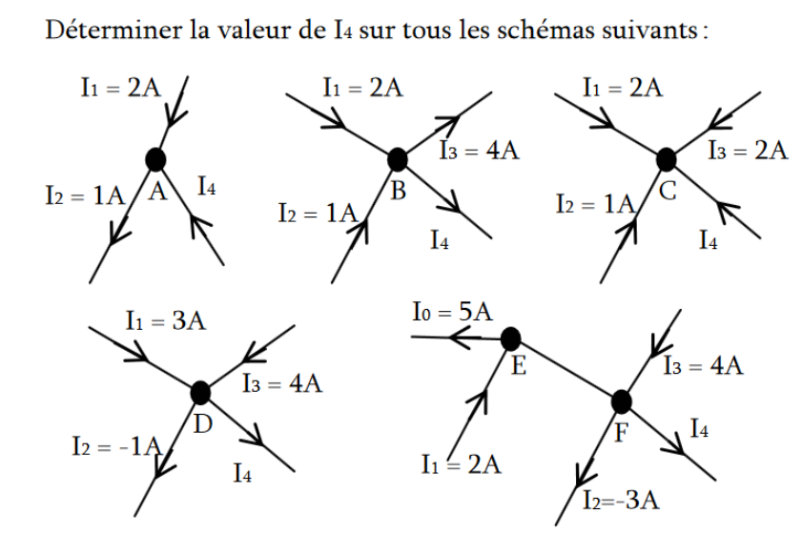

Exercice 2:
Calculer i sachant que V=5V, R1=100Ω, R2=1kΩ et R3=10k Ω



